Prokaryotic Protein Expression Service Order Application
Please fill in the form as detailed and accurately as possible. Sufficient communication will help us provide you with better and faster services. Thank you!
Contact number:
Email:
Customer Basic Information Registration
Name: | Institution:
Contact Phone: | Email:
Mailing Address: | Research Group Leader:
Affiliated Research Group:
Sales Representative: | Sales Rep. Phone:
Commitment from the individual/institution regarding samples or sequence information (DNA/RNA/amino acids) provided to Sangon Biotech:
The materials have no pathogenicity or infectivity, or the samples have been fully inactivated to lose their pathogenic and transmissible capabilities; the involved nucleic acid or protein sequences (DNA/RNA/amino acids) have no relevance to pathogenic and infectious pathogenic microorganisms (such as the COVID-19 virus sequence, etc.); the transmission and operation of the samples are within the scope permitted by national, regional and relevant organizations; there is no material or information related to Chinese human genetic resources; we agree to the return of the samples after use.
Replying to or confirming this order/sample information form via email shall be deemed as agreement and acceptance of all contents in the order/sample information form.
Committer: ____________ Date: ____________
Overview of Prokaryotic Service Items
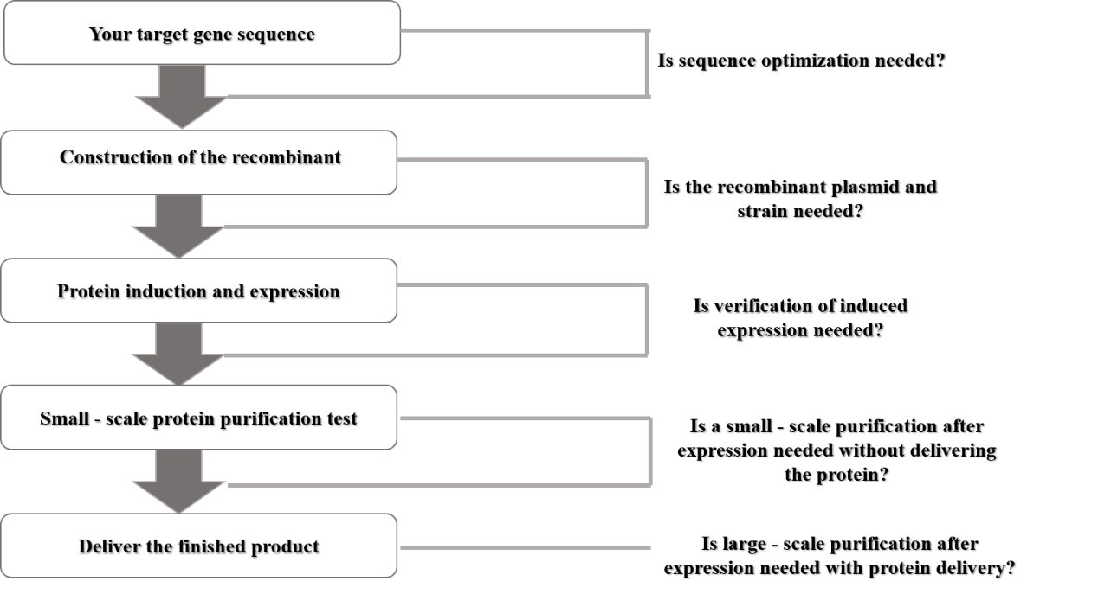
Service Type Selection
Plasmid:
☐ Need construction ☐ Provided by customer
Delivery: Sequence optimization report (if applicable).
Protein:
☐ Expression test (to check induction results)
Delivery: Recombinant plasmid and sequencing report (if constructed), bacterial strain containing the plasmid, project conclusion report.
☐ Expression and purification test (to check expression and purification results, no protein delivery)
Delivery: Recombinant plasmid and sequencing report (if constructed), bacterial strain containing the plasmid, project conclusion report.
☐ Expression, purification and preparation (expression + purification + preparation, with protein delivery)
Delivery: Recombinant plasmid and sequencing report (if constructed), bacterial strain containing the plasmid, purified protein, project conclusion report.
Information Provided by Customer
1. Gene and Protein Information
Gene/Protein Name
GenBank Accession No. or Sequence Link
Species Source
Target Protein Nucleic Acid Sequence
Target Protein Amino Acid Sequence
Plasmid Source | ☐ Expression plasmid or glycerol stock provided by customer (To ensure smooth experiments, please provide recombinant plasmid map, restriction sites, sequencing files, host strain, etc.)
Plasmid Source | ☐ Expression plasmid constructed by our company: full gene synthesis without sequence optimization
Plasmid Source | ☐ Expression plasmid constructed by our company: full gene synthesis with sequence optimization
2. Requirements for Purified Target Protein
Fusion Tag | Whether fusion expression with tags such as HIS, GST, MBP is acceptable  ☐ Not required (no purification tag, only expression test, no purification)  ☐ Acceptable (please specify tag: ________) Tag position: ☐ 5’ end ☐ 3’ end
Fusion Tag | Whether the fusion tag needs to be removed from the fusion protein (removal is avoided if possible)  ☐ Need removal ☐ No removal
Fusion Tag | If tag removal is required, any preference for protease recognition site between tag and target protein (additional cost and time required)  ☐ Tobacco Etch Virus protease/TEV ☐ SUMO protease ☐ Enterokinase/EK ☐ Other protease: ________
Final Protein Preparation Specifications | Quantity ≥ ____ mg (e.g., 1, 3, 5…)  Purity ≥ ____ (e.g., 80%, 85%, 90%) (determined by SDS-PAGE electrophoresis)
Concentration | Default ≥ 0.3 mg/ml  Other requirement: ≥ ____ mg/ml (higher concentration requires additional cost and time).
Protein Storage Buffer | ☐ Default: 50 mmol/L Tris, 150 mmol/L NaCl buffer system (may contain glycerol depending on circumstances)  ☐ Other: ________  Note: If specific components must be avoided in the buffer, please inform us before the project starts.
Endotoxin | ☐ Endotoxin control required  ☐ No endotoxin control required
Subsequent Use of Protein | Purpose: (e.g., antigen, enzyme activity assay, raw material for biochemical experiments, protein crystal structure research, cell culture additive, etc.)  Note: Activity is not guaranteed. We will try to purify the target protein from the supernatant (supernatant protein best maintains natural conformation), but if purification from supernatant is difficult, the protein will be purified from inclusion bodies and dialyzed.
Other Special Requirements
Protein Shipping Status | ☐ Default: liquid  ☐ Lyophilized (additional cost and time required)
Acceptance Criteria | The final purified protein will be accepted if:  1) SDS-PAGE shows the purified protein meets the theoretical molecular weight and purity requirements;  2) WB detection is performed if necessary.  Note: Purified protein meeting the above criteria is deemed qualified.
3. Previous Experiment Attempts by Customer
No prior expression attempts | ☐ No expression detected. Possible reasons: ________
Previous expression experiments | ☐ Expression detected, only in supernatant  ☐ Expression detected, only in precipitate  ☐ Expression detected in both supernatant and precipitate  Please attach expression result images and indicate molecular weight.  Customer’s expression conditions: ________
If inclusion bodies formed, whether renaturation was attempted | ☐ Yes. Renaturation conditions: ________ Result: ________  ☐ No
Attempted purification methods or methods from literature (please attach documents)
4. Other Supplementary Information

